**ANKIT CHAUHAN**

B.tech(CSE)-I.T.S Engg.College,Gr.Noida.   
 Add-Shri Sai Heritage,Ghaziabad,U.P.  
 PhoneNo.9717201841.   
 Email- ankitchauhanhs_cse16@its.edu.in   
 Visit: https://ankit2000-code.github.io/resume5/

____________________________________________________________________________________

**OBJECTIVE:**

**"**Seeking a position to utilize my skills and abilities in the Information- Technology that offers Professional-experience and Future-growth".

**SKILL SETS:**

* Good Presentation Skills.
* Analytical Skills.
* Reasoning ability.
* Team Player.

**COMPUTER SKILLS:**

* **Programming Languages:** Core Java, Servlet-JSP, HIBERNATE and Basic Knowledge of C.
* **Server:** Apache Tomcat-9.0, Oracle WebLogic 12C and Git/GitHub.
* **Web Desiging:** HTML, CSS, JS.
* **Operating System:** Windows.
* **Others:** Data Structure and Algorithms.

**Educational Qualification:**

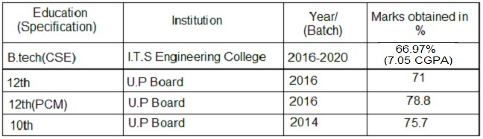

**CERTIFICATION:**

* Completed 12 months **Java Training**From 'Ducat india pvt ltd' Noida.
* Participated in the one day **Bootcamp on Java Technology** Conducted by ‘**RealCoderZ Technology**’.
* Completed **Career emboldening training program** by RuralShores skills academy.
* Got first rank in District level eassy writing competition.

**Academic Project:**

❖ Bank Website Project :

Login,signup,Personal banking,Corporate bankig,otp- generate,Transactions....etc

Using Oracle weblogic 12c server and mysql database.  E-Farming Web application :

**Hobbies:**

* Problem Analysis and Solving it.
* Listening Classical Songs and Reading Books.

**Personal Profile:**

* Father Name: Mr.Harpal Singh Chauhan.
* DoB: 31 December 2000.
* Nationality: Indian.
* Gender: Male.
* Hometown: Budaun,Uttar Pradesh.
* Language: Hindi & English.

________________________________________________________________

**\*\*\*\*\*\*\*\*\*\*\*\*\*\*\*\*\*\*\*\*\*\*\*\*\*\*\*\***

I hereby declare that all the information mentioned in my resume is true and correct to my knowledge and I take full responsibility for the accuracy of the particulars mentioned.

**Date: / /2021 Candidate name-** Ankit Chauhan

**Signature-**

________________________________________________________________

**\*\*\*\*\*\*\*\*\*\*\*\*\*\*\*\*\*\*\*\*\*\*\*\*\*\*\*\***